Evidencias de reuniones
Daily Meeting 24/09/2026
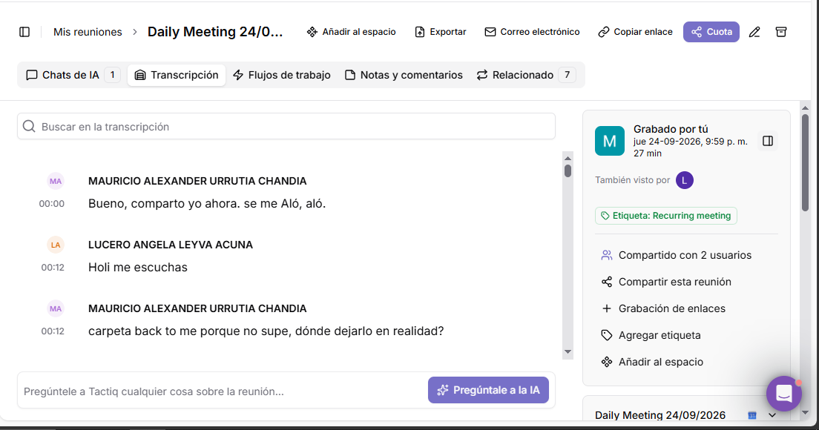
Daily Meeting 25/09/2026
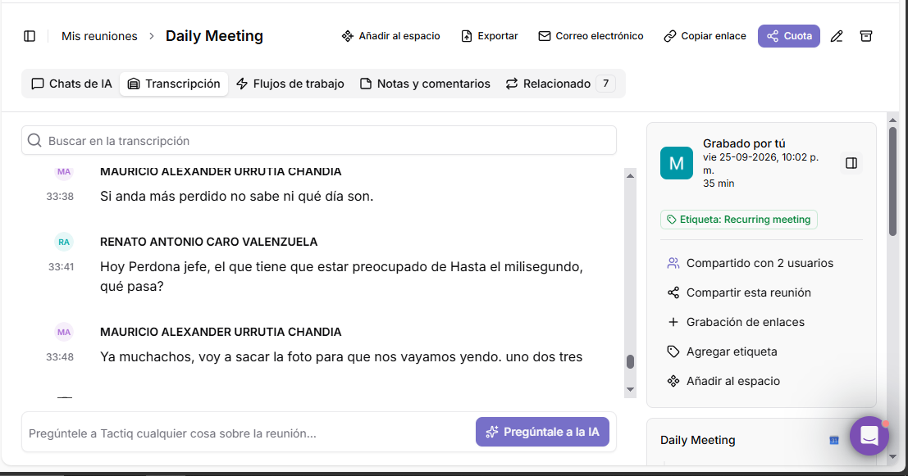

Daily Meeting 29/09/2026
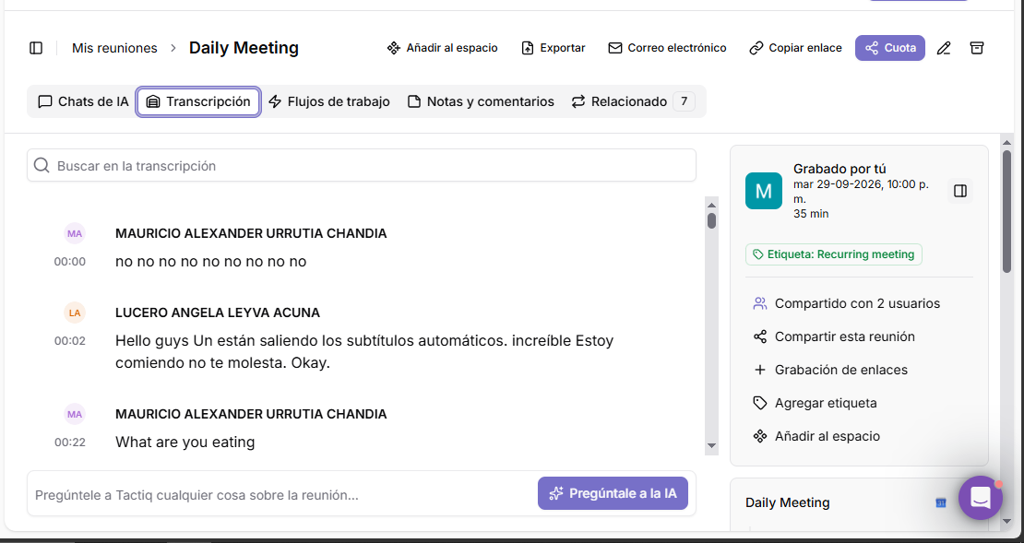
Daily Meeting 01/10/2026
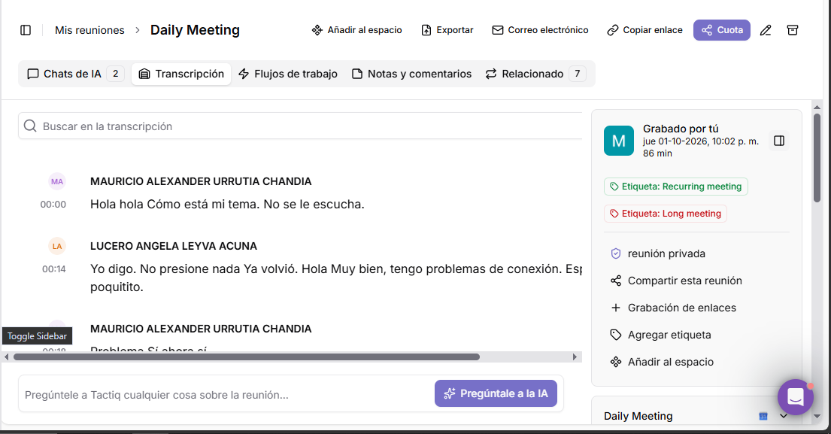

Daily Meeting 02/10/2026
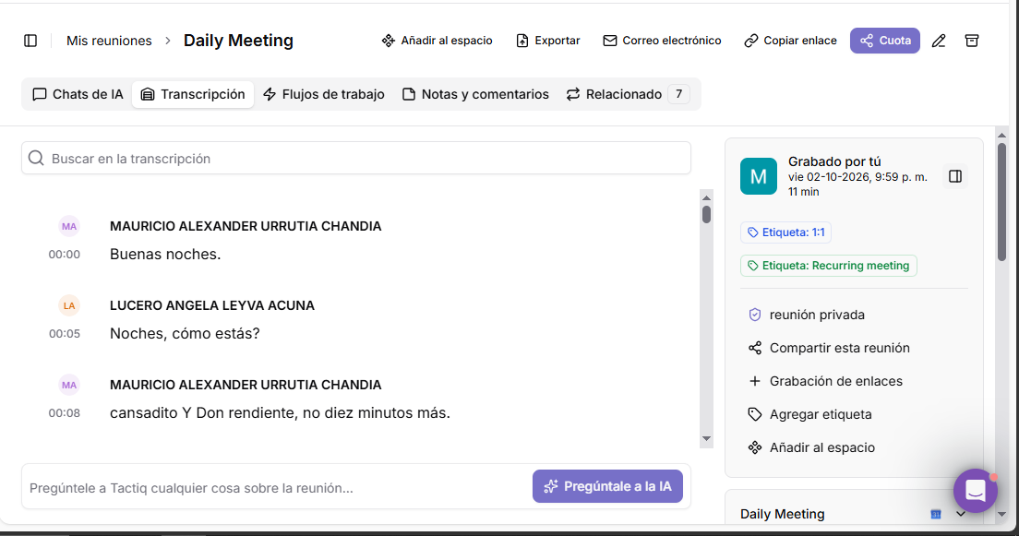
Daily Meeting 05/10/2026
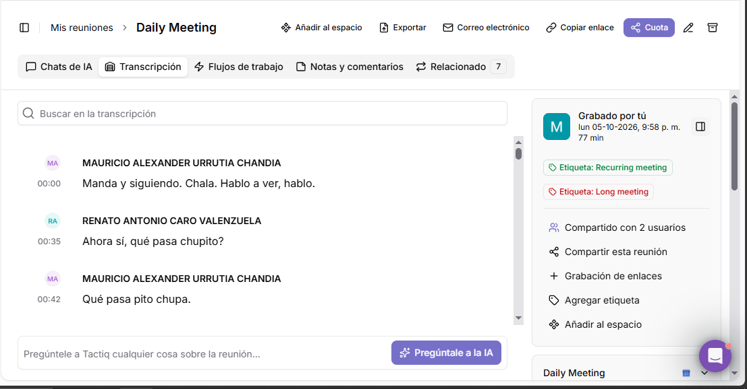

Daily Meeting 08/10/2026
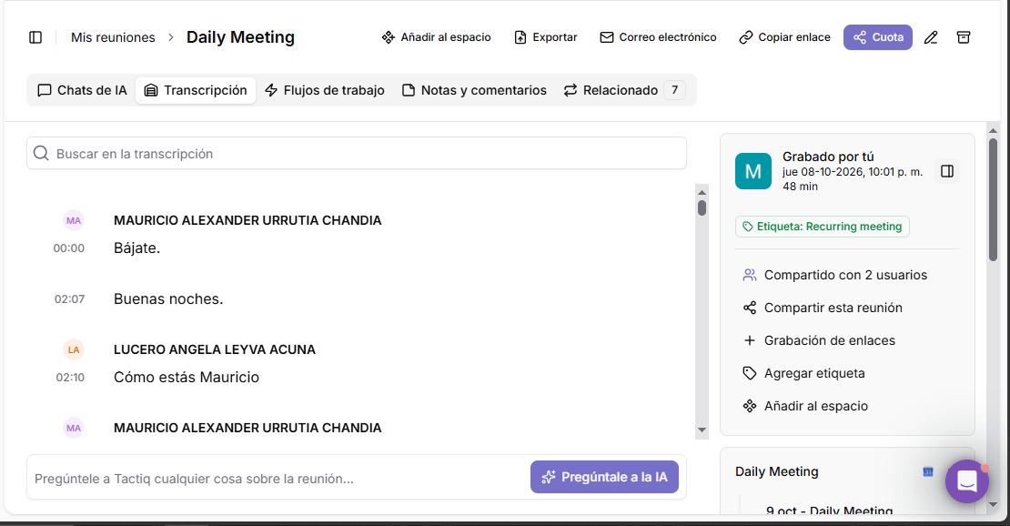
Daily Meeting 09/10/2026
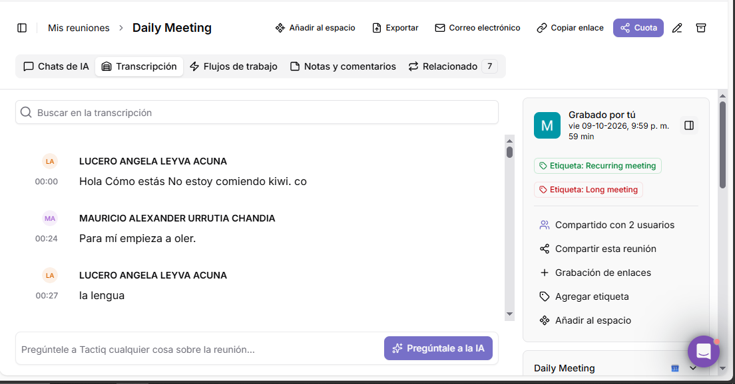

Daily Meeting 13/10/2026


